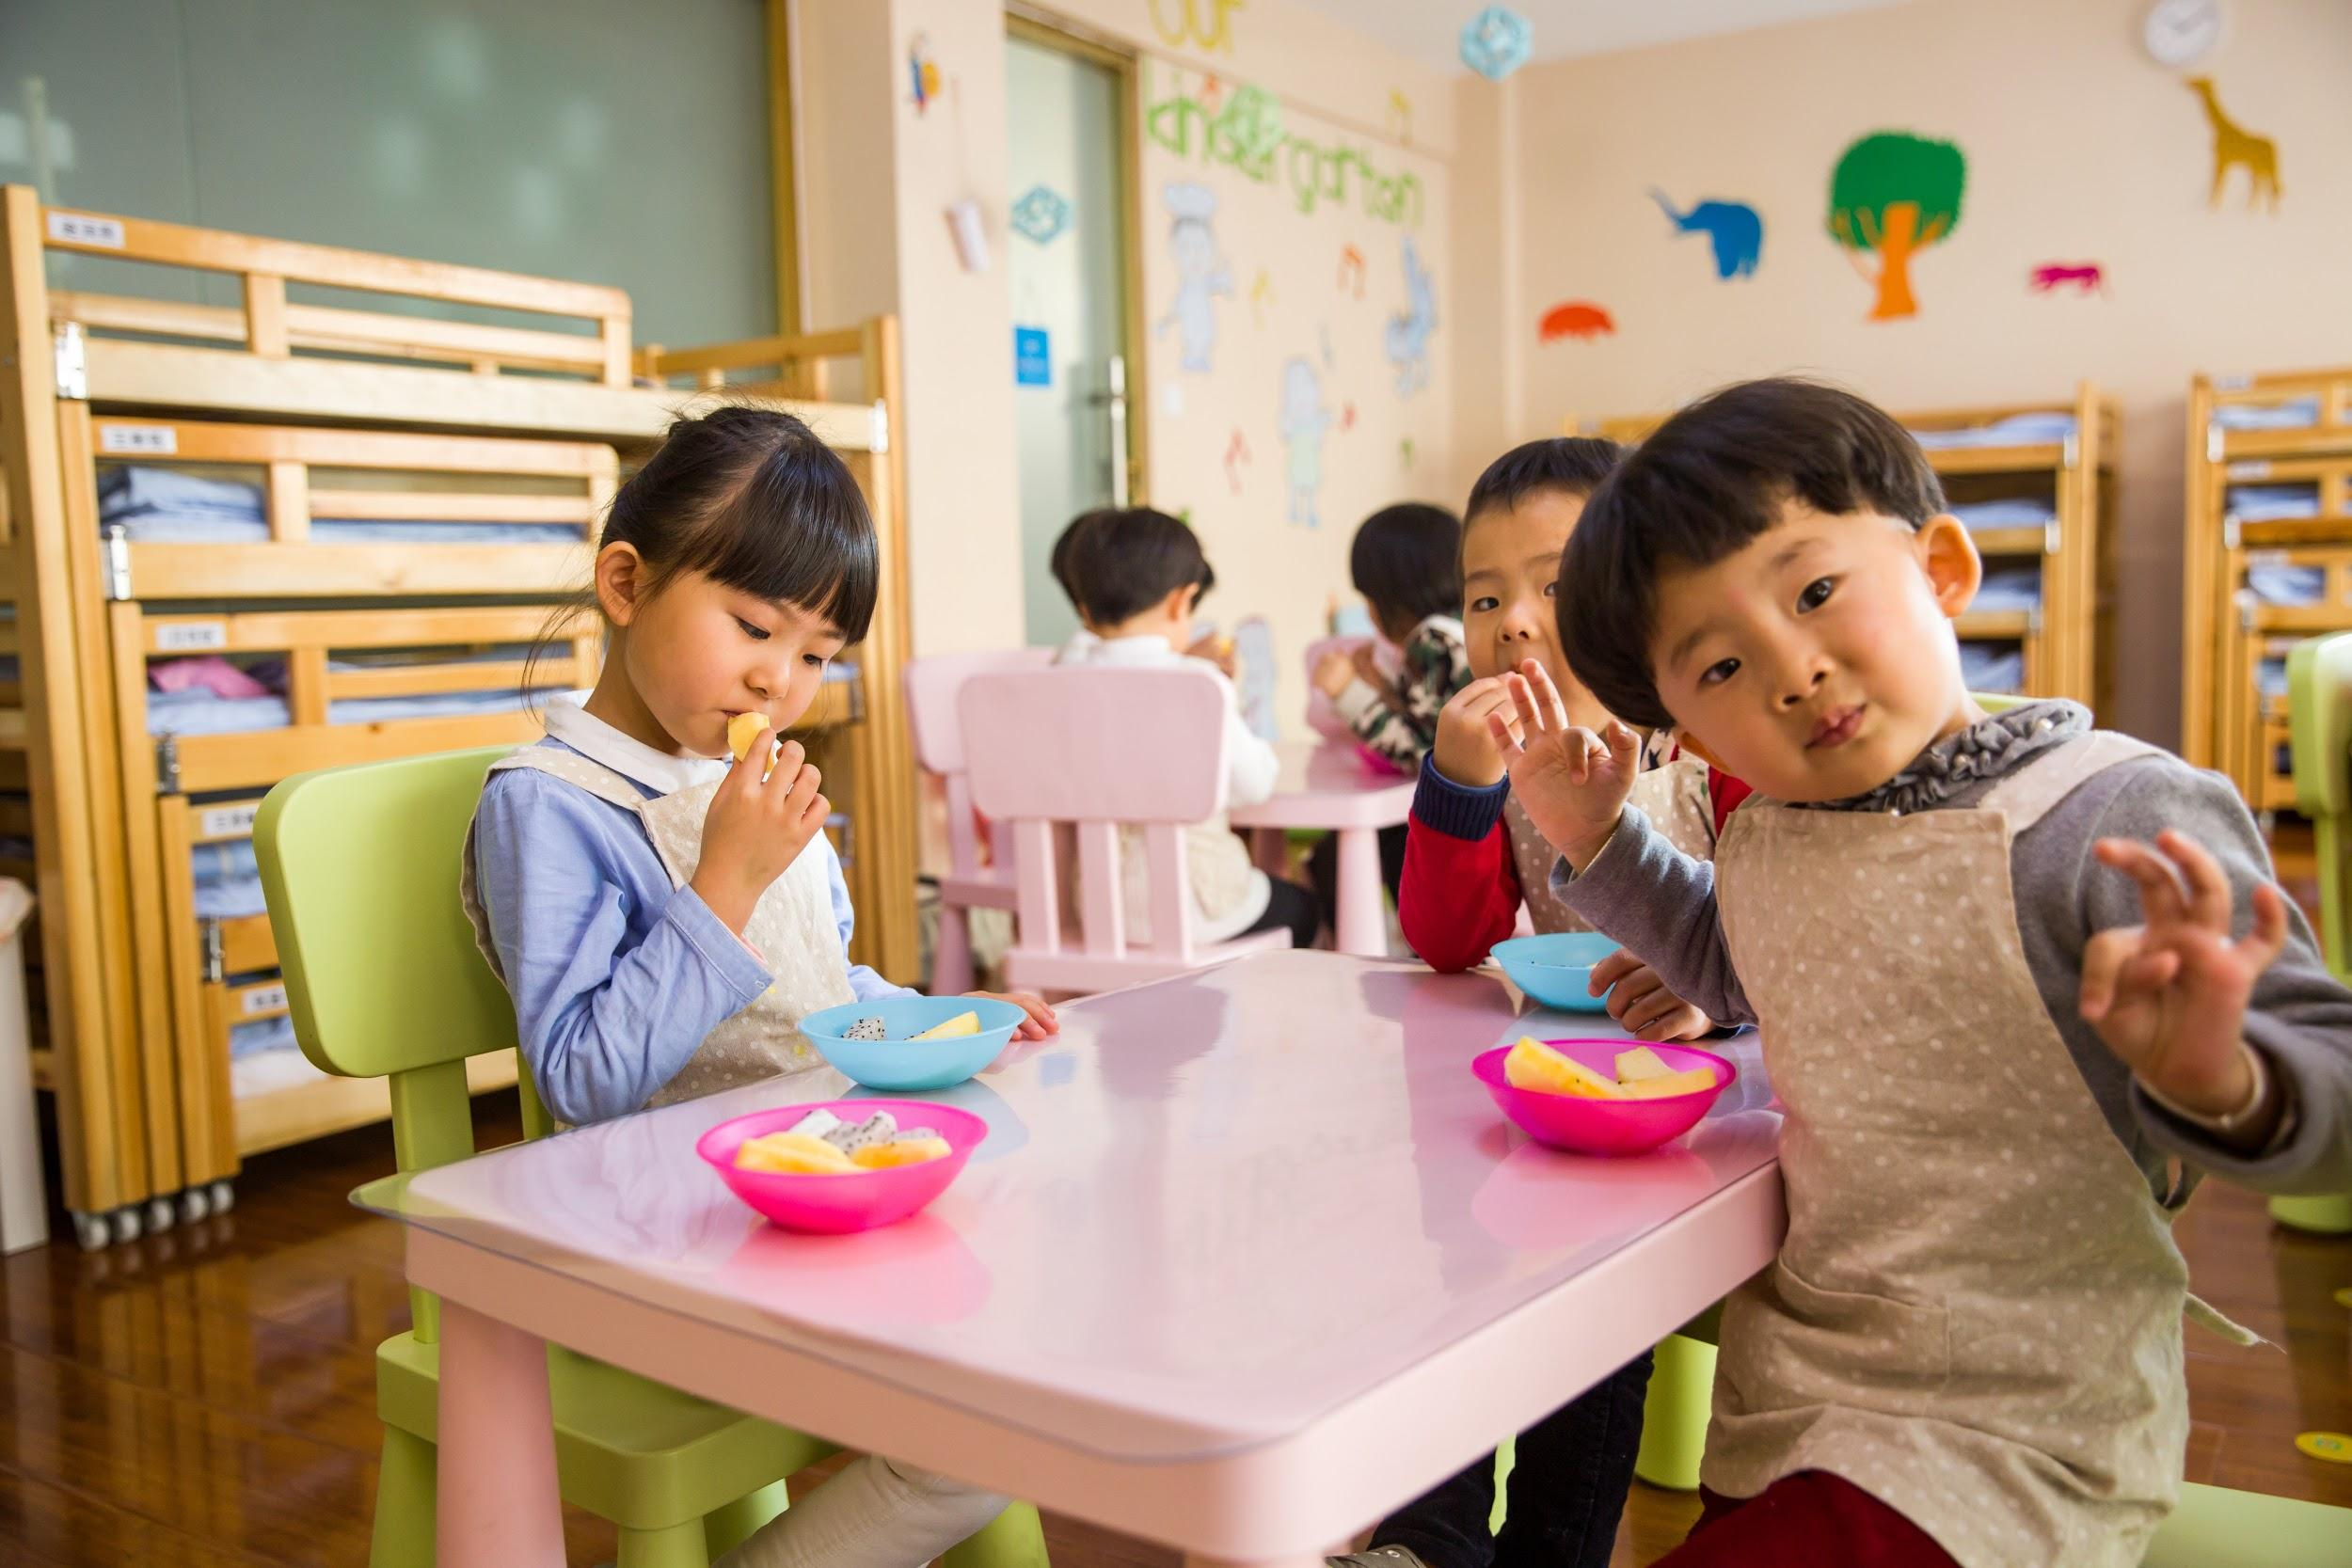
Image via Pexels

A Parent’s Guide to Raising Children Through Every Major Stage

From promoting your baby’s cognitive, emotional, and physical development to helping your grade-schooler study for a history, math, or science test, you’ll wear many hats as a parent — with caregiver, coach, and cop being just a few of them. While your parental responsibilities will change as your child grows older, the following resources will help you to give your little one the things he or she needs most throughout each major stage in life.

1. Babies
Your Ultimate Checklist of Baby Essentials
A Guide for First-Time Parents: What You Need to Know
Encouraging Your Baby's Development from 0 to 12 Months

2. Toddlers
Toddler Parenting Tips for 1- and 2-Year-Olds
10+ Effective Strategies to Mitigate Difficult Toddler Behavior
Get Moving! Toddler Activities to Encourage Physical Development

3. Preschoolers
13 Tips for Starting Preschool: Ease the Transition for You and Your Child
The 5 Things Children Really Need to Learn in Preschool
7 Educational and Entertaining Activities for Young Kids

4. Grade-Schoolers
5 Tips for Avoiding Homework Battles with Your Grade-Schooler
Helpful Tips for Homeschooling Math
Discipline Tips for School-Age Children

5. Teens
20 Ways To Motivate Your Teenager To Study
How Independent Should Your Teenager Be?
5 Effective Tips On How To Discipline A Teenager

Whether your child is three months, three years, or 13 years of age, your little one will always rely on you for guidance, encouragement, and love. Your child’s wants and needs will certainly change over time, but these tips and resources will be there to guide you along the way.

